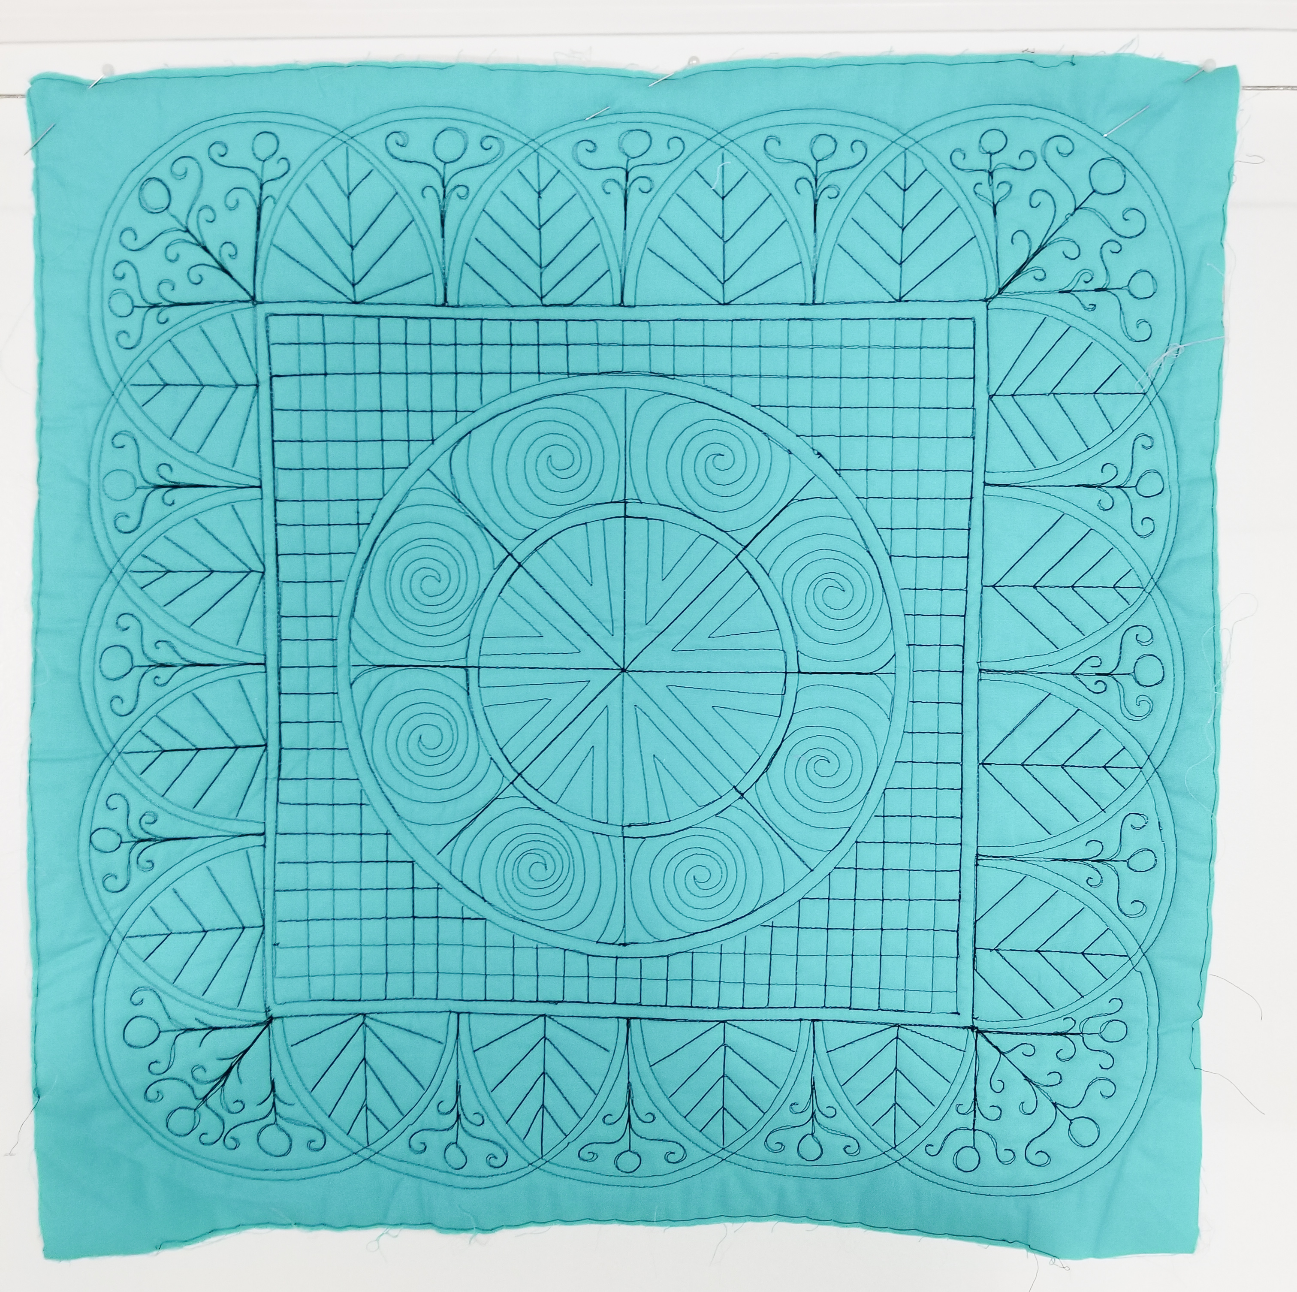

Welsh Quilting Workshop
With
Tia Curtis

Join Tia Curtis as she makes intricate, glorious Welsh Style quilting as easy as pie. Tia Curtis will give you a little history on the most beautiful and passionate of all the quilting styles and break down the designs into simple steps for you to elevate any border into an instant show stopper. She will also show how to work in some fabulous medallions. You will learn to mark your quilt with minimal lines and incorporate some of the best quilting rulers to quilt the bones of several border styles then fill them in with the best Welsh designs. While the quilting looks complicated it is just a matter of taking the proper steps and knowing a couple tricks. These skills can be used on the long arm or on the domestic machine. If you are a hand quilter, the same techniques will work for you as well.

Supplies:

- Two 20-inch squares of fabric (I recommend a solid so you can work on your design and stitches. Prints can be busy and the results of your work will not be as strong)
- Batting and backing for the 20-inch squares. (I love wool batting for this technique).
- 24-inch x 6-inch quilting ruler
- **Circle templates. (There are many acrylic circle ruler sets available for marking your quilt. Any will do or you can borrow one of mine. You can also make your own templates with a cardboard from a cereal box, so it that is how you want to do it bring a large cereal box and scissors to cut it.)
- Fabric marking pen (Clover, or Sewline blue water erasable pen or white chalk of your fabric is dark)
- Safety pins or basting spray
- Pencil and Sketchbook
- Sewing machine in good working order with walking foot and free motion foot. If you have a ruler foot for your machine you can use that as well.
- Thread of your choice

*Please bring $5 for workbook handout
** I will have half Circle Acrylic rulers available for purchase ($40 for a set of 6 nested Half Circle rulers) as well as a set of my own for use in class

If you have any questions prior to class please email me at tia@tiacurtisquilts.com

www.tiacurtisquilts.com

